Career Guidance Cell Activity-02
Talent Hunt on Banking Services – conducted by Sri Sai Krishna Bank Coaching Centre , Kurnool (Dt).
Sl.No. : | 01
Name of The Department | Department of Political Science
Name of The Event Organized | ‘Talent Hunt’-Programme on Banking Services conducted by Sai Krishna Bank coaching centre, Kurnool(Dt)
Title of The Event | ‘Talent Hunt’-Programme on Banking Services conducted by Sai Krishna Bank coaching centre, Kurnool(Dt)
Date of The Event Organized | 24-02-20223
Name of The Co-Ordinator of The Event | Dr.M.Indira Santhi, Principal  Dr.M.C.Sahitya,Convener, Lecturer In Political Science  Co-ordinator, Career Guidance Cell,  Member’s:--  - Kum.G.Vijaya Lakshmi, Lecturer.in History,  - Smt.Vishnu Vandhana, Lecturer. In Computer Science,  - Smt.A.Jaya Lakshmi, Lecturer. in History  - Smt.B.Sujatha, Lecturer in Zoology.
Class of The Participant | I, II and III Year students of all Groups
No. of Participants( Students And Staff) | 196 students, 07 Staff members
Web Link of The Event
Name of The Expert With Designation | 1.Mr. N. Immanuel, Manager, Sri Sai Krishna Banking coaching centre, Kurnool  2.G. Gangadhar shiva, manager -technical advisor, Sai krishna banking coaching centre, Kurnool
 | 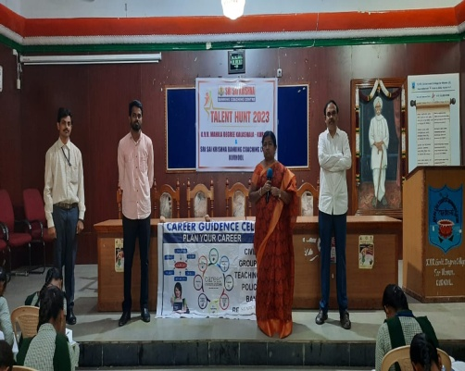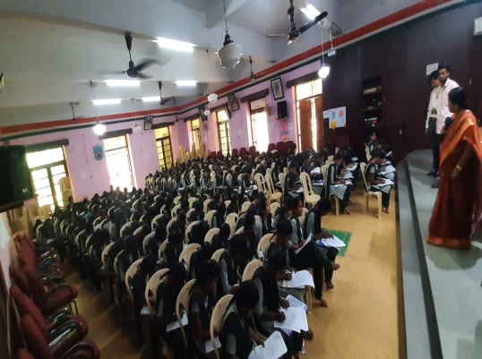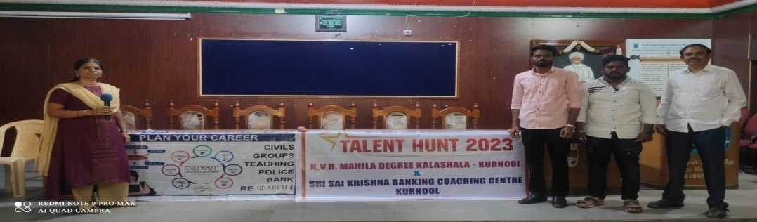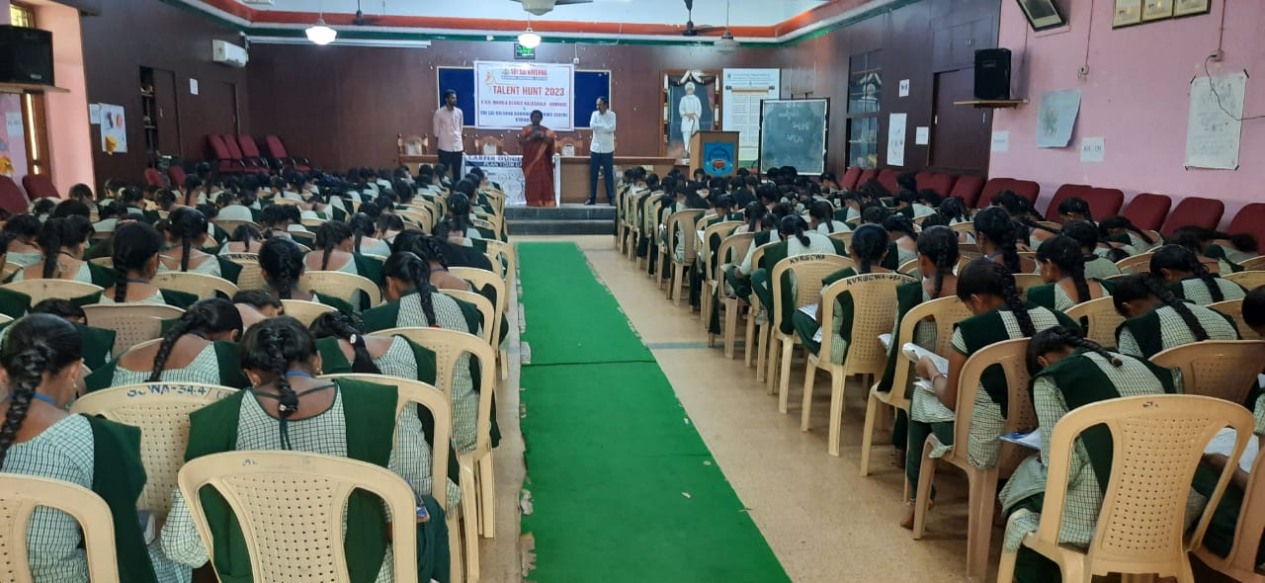
Objective of the Event | - To Provide An Awareness Programme on Competitive Exams by Mental abilities, Arithmetic, General English (Dt)  - To promote capacity building to students on Mental abilities, Arithmetic, General English through this Career Guidance Cell forum
Outcome of the Event | - Students attained awareness on Competitive Exams through this Career Guidance Cell forum  - All students Attained Knowledge on Mental abilities, Arithmetic, General English.
Brief Report of The Event:- An ‘Talent Hunt’-Programme on Banking Services conducted for students on Competitive Exams under supervision of Dr.M.Indira Santhi, Principal and Dr.M.C.Sahitya, Convener, Career Guidance Cell, Member ‘Talent Hunt’-Programme on Banking Services conducted by Sai Krishna Bank coaching centre, Kurnool(Dt).The Resource person was Mr. N. Immanuel, Manager, Sri Sai Krishna Banking coaching centre, Kurnool, and G. Gangadhar shiva, manager -technical advisor, Sai krishna banking coaching centre, Kurnool, Dr.M.C.Sahitya, Convener , Head, Lecturer In Political Science. Dr.M.Indira Santhi, Principal Dr.M.C.Sahitya, Convener, Career Guidance Cell, Members-Kum.G.Vijay Lakshmi, Lec .in History, Smt. Vishnu Vandhana, Lec. in Computer Science, To promote capacity building to I, II and III Year students of all groups from Arts and commerce streams nearly 196 students, 07 Staff members participated in the event.

